Lab Activity {Change the title}
Submission Form

Name
Section
Date
Place output based on the source code.
Attach your screenshot here.

Place your sample code and output based on the enhancement.
Source code |  | Output
Example: |  | Example  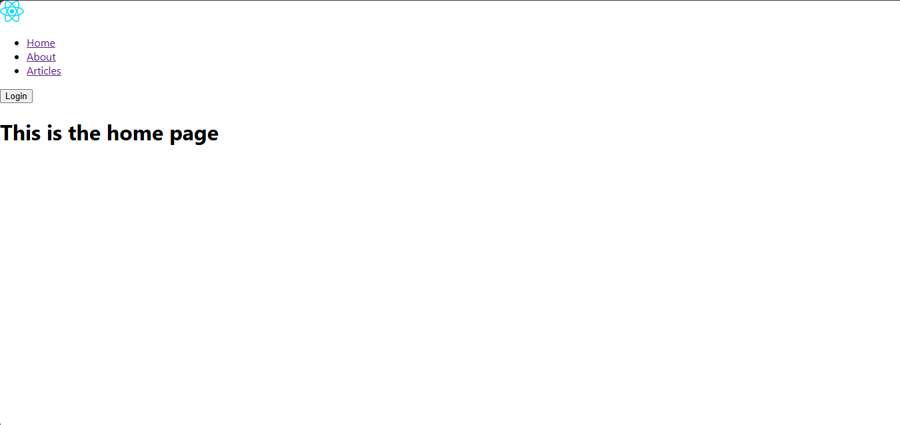

Lab Activity Rubric {Copy and paste the Rubric here}

Name
Section
Date

Criteria | Excellent (4 pts) | Good (3 pts) | Fair (2 pts) | Poor (1 pt) | Points
 | Other Comments/ Observations: |  |  | Total Score
 |  |  |  | Rating: (Total Score/24) * 100

